Dear Neighbour
You may not be aware that I was disturbed by noise from your property
On……………………………………..(date) at …………………………….. (time)

I could hear
□  your TV ꟾ □  your music ꟾ □ 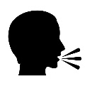raised voices
This Photo by Unknown Author is licensed under CC BY-SA-NC

□ Other……………………………………………………………………………………………………
This meant I was unable to

□ 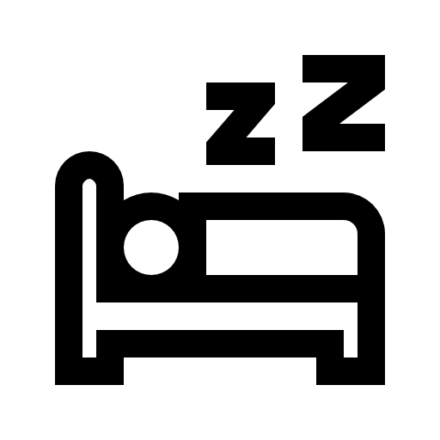Sleep ꟾ □ 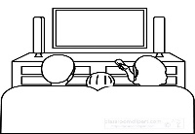 Hear my TV ꟾ □ 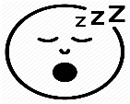My family were
disturbed

□ Other……………………………………………………………………………………………………

I’m sure you weren’t aware you were causing a disturbance and I would be grateful if you could try to avoid it happening again so we can all enjoy living in our homes.
Thanks for your co-operation and Kind Regards

